Assessment of the publication of Age information
Data Group NES
June 2020

Information is published quarterly on the staff in post directly employed by NHSScotland. This data is extracted from the Scottish Workforce Information Standard System, processed and reported via interactive dashboards and excel tables and supported by a summary and report (produced annually).
These data were previously produced and reported under the National Statistics badge by ISD until September 2019 (30 June census). Publications in December 2019 and March 2020 (30 September and 31 December census respectively) were produced by the NES Data Group following the ISD methodology and publishing standards and hosted on the ISD website. From June 2020 (31 March census) the NES Data Group will have full responsibility for processing, reporting and publishing these Workforce Statistics on Turas Data Intelligence under Official Statistics badge.
A range of indicators are reported via the publication outputs: NHS Board, Staff Group, Sub Job Family/Specialty, AfC Band/Grade, 5-year Age Group, Sex and Contract Type. The provision of this information adds value by providing a single source of reporting indicators crucial to workforce planning which can be used, for example, to identify gaps in the workforce and implement strategies to mitigate this impact on the provision of care. Additionally, we have a requirement to meet our public sector equality duties under The Equality Act 2010 (Specific Duties) (Scotland) Regulations 2012 and The Equality Act 2010.
The provision of this information must also satisfy data protection law, information and statistical governance guidelines, and best practice, to:
- protect the identity of people employed by NHSScotland from disclosure of sensitive information,
- ensure trustworthiness in reporting capability and
- mitigate against reputational damage.
As the responsibility for the publication of workforce statistics now lies with NES, a review into the publication outputs has taken place, with a focus on the public availability of age data. In addition to best practice, this review was in part motivated by a historical complaint raised to ISD by a health board around the granularity of age data.
Specifically, the level of age group information available allows a motivated individual to discover the age of a person where numbers <5 are involved. This can occur through tracking a cell with one individual through different census dates and identifying when they change age group. Therefore, the date of birth can be estimated within three months.
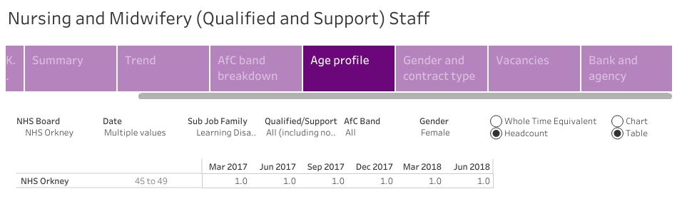
Source:
http://www.isdscotland.org/Health-Topics/Workforce/Publications/2018-09-04/Nursing-and-Midwifery.asp
Data as at quarter ending 30 June 2018, published by ISD Scotland on 4 September 2018
In response to the complaint, the ISD Statistical Governance team undertook a risk assessment of the publication of age data in the Workforce statistics. They concluded that the level of age information available was not suitable for public consumption given the emphasis, under GDPR, on protecting the rights to privacy and freedom of individuals. Specifically, the risk score comprised the likelihood of an attempt to disclose (score 2) x Impact of disclosure (score 2) which = 4; thus, requiring the data to be protected.
The Data Group and Information Governance at NES have considered the current risks associated with the release of age data available in the dashboards, and the evidence provided in the ISD risk assessment, and agree on the following:
- The age of workforce staff should be treated as a protected characteristic and is personal data in accordance with data protection law.
- The current dashboards have several variable breakdowns in addition to age. Therefore, a motivated individual could also use the age data to learn other facts about an individual.
- The requirement to balance risk of disclosure with data utility.
- There is value in reporting age data to the public at an aggregated level (by NHS Board and Staff Group) where the risk of disclosure is mitigated. The added value of releasing age data at a more granular level (for example, along with Job Sub Family / Specialty, AfC Band / Grade and Sex) does not outweigh the risks of disclosing personal information to the public. Public interest scenarios have also been considered in reaching this conclusion.
- Adopting Statistical Disclosure Control protocol is not feasible due to the complex range of scenarios which would require suppression. Furthermore, if suppression fully mitigated any risk of disclosure of age, it is likely the output would minimise data utility (at granular levels).
- It is important to continue to supply colleagues working in workforce planning, reporting and intelligence with the appropriate level of age information so that their work is undisrupted.
Drawing on the above conclusions, the following proposal for the release of age information is:
- Public release of age in quarterly reports will be restricted to age distribution by NHS Board and Staff Group. This data minimisation should facilitate our duty to inform the public of the current age distribution of the workforce whilst working within the appropriate information governance. (This will mostly affect the dashboard outputs.)
- Additional dashboards will be available behind secure log-in (on TDI) with age data broken down by variables required for workforce planning, reporting and intelligence functions. Colleagues at NHS Boards and Scottish Government whose work requires access to these data will be granted permission based on their role and need to know. This access will be controlled by the Data Group.

